Weekly Progress Report for INTP Final Project: Sound visualizer with p5js

* Template Choice: Sound Visualizer
* Questions
  + What progress have you made this topic?

So far I have made circular particles shooting from middle to edge with Sound visualizer FFT functions on it.

And end of this project the template will have a Perlin noise visualization with FFT function on it. So that It shows more noises and effect on screen as music plays.

Also I would like to implement few more modifications and extensions to template as we learned about GUI

* + What problems have you faced and were you able to solve them?

There was some misunderstanding with the final project. I did not know that we had to implement our own visualization on a existing provided file. So that I had to combine my own project file which I submitted for interim project to the file provided musicVis- master. Some of the variables and functions, syntaxes were not in same format as Vismaster.

* + What are you planning to do over the next few weeks?

I have planned on excel spread sheet for goals to do by weekly. Also actual actions that I took for each week according to the plan. Please refer to this planner and Gannt below/ Moreover summarized written as this:

* + - Ongoing project upgrade: The interim project submission was not the completed project, I will be upgrading more features, and visual effects.
    - New sound visualizer – Perlin noise visuals(Speaker shaped)

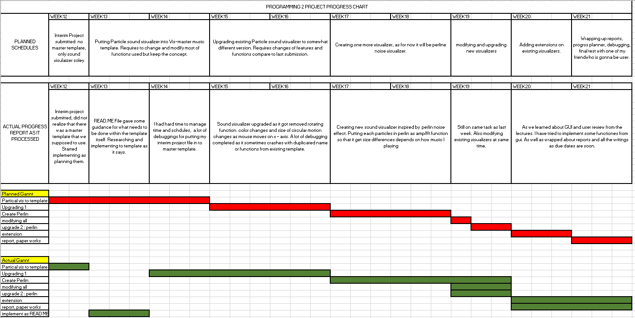

Are you on target to successfully complete your project? If you aren’t on target, how will you address the issue?

* + - Initially I have planned that I would be doing tasks accordingly as I planned, without duplication of works and wanted to make smaller and smaller works as the due dates get closer. However, that was not same as reality, there were a lot of circumstances in life where I just could not get on my computer and start coding. In order to meet the due date and deadline I had to rework all the other things repeatedly even thought I supposedly already finished them. For an example on week 19 I knew myself that I had to finish Perlin project if it went as I planned however I had to continue working on them as well as extensions and reports.